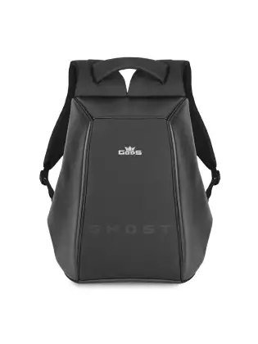

**$1000.00**

**Description**

Has Great Backpacks For College Students And Adults, Too. They Sport Large Compartments That Can Hold Books, Binders, Lunch Bags, Gym Clothes, Travel Clothes, Toiletries and More You Can Find Backpacks With Built-in Sleeves For Laptops And Tablets. They Also Have Front Organizer Pockets for Keeping Essentials Handy, And Some Even Have Side Water-bottle Pockets. Our Backpacks For Kids Come In Bright Colors And Cool Designs For Every Kind Of Student From K–12. They’re Comfy to carry and Made to Last with Tough Fabrics, Sturdy Zippers and Strong Stitching.

Bagpack Bag’s

**Bag**

Self-winding mechanical movement. Caliber 324 S C.

**Chest Clasp**

Bag Back Strap with a Chest Clasp. Bear a Solid and Simple.

**Resin Buckle**

Wear Durable and lockable Cheney lock

**Body**

4mm thick genuine vegetable dyed lather

**Reinforced Dates**

School Bag Force Parts of the Multi-car Line to Strengthen the Process of Processing Date. Increase the bag Bearing Capacity..

